MC900391170[1]Once you rename the review configuration, you must attach it to your workflow grouping.

1. Select the Workflow Definition tab, select the ProjectFlow Building LAB for example, and click the V to show the versions.  
   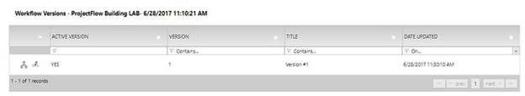
2. Choose the first icon, Open Workflow Designer.
3. Select the Department Review Grouping.  
   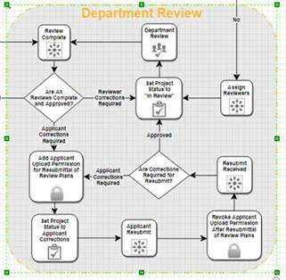
4. Select the “I” icon at the bottom right then choose the Review Configuration, Building Import, Save.  
   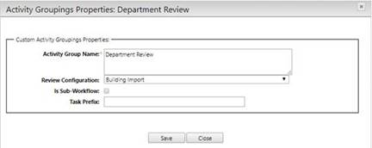
5. Edit the 3 default review configuration names in the 3 Department Review groupings inside the 3 sub workflows. Here is an example of the first grouping, Building Plan Review which is inside the Building Sub-Workflow, click on the small “i”.  
   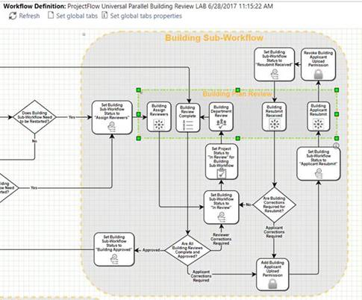
6. Select the correct Review Configuration. Notice that at this level the Sub-Workflow is not checked. Save and Close.  
   