**Tuning the ProjectDox database using SQL Profiler, and Tuning Adviser**

**NOTE**: The interface of the tools may vary with the version of SQL Server you use. Please consult Microsoft’s web site or other documentation for additional information.

**IMPORTANT!** Running the SQL Profiler and Tuning Adviser should be undertaken only by persons sufficiently familiar with SQL Server. The tools create temp files, and care must be taken not to fill up the system drive. Use this guide at your own risk. Avolve Software is not responsible for any damages.

1. Confirm you have ProjectDox standard users, Project Admin, and System admin logins and passwords, and the URL for the site
2. Open SQL Server Profiler (in SQL Management Studio)
3. Select File, New Trace
4. Login as an SA on the SQL Server

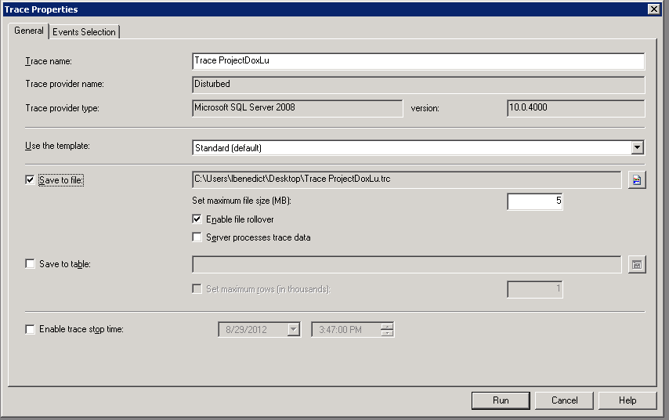

1. Select the Events Selection tab
2. Check Show all Columns checkbox
3. Click the Column Filters button
4. Choose Database Name
5. Expand **Like** on the right side of the window, type the name of your ProjectDox database (in the example ProjectDoxLu,) and then click **OK.**

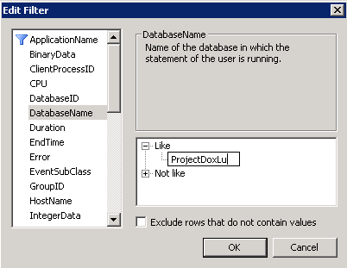

**NOTE**: The actions describe in the next step are for general tuning. Your purpose for tuning may vary, and you may select specific activities to trace and tune (for example: logging in as a user with membership in many projects, waiting for the project list to display)

1. Click **Run** when you are all ready to start.
   1. Login as a low permissioned user. Use PD – view projects, files, folders, Eforms, etc. (Better if multiple active users are doing it live)
   2. Login as PA, SA. Use ProjectDox – view projects, files, folders, Eforms, etc.
2. Stop trace
3. Open database tuning advisor
4. Choose Workload, File radio button
5. Navigate to the Trace file
6. Choose the Database for workload analysis
7. Place a checkmark next to the name of the database

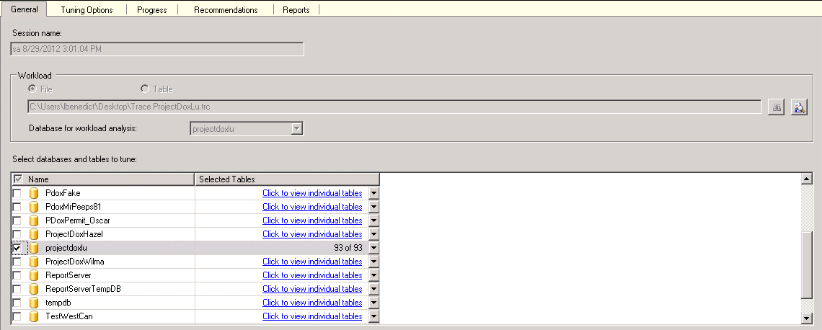

1. Click the Start Analysis button at the top of the Advisor

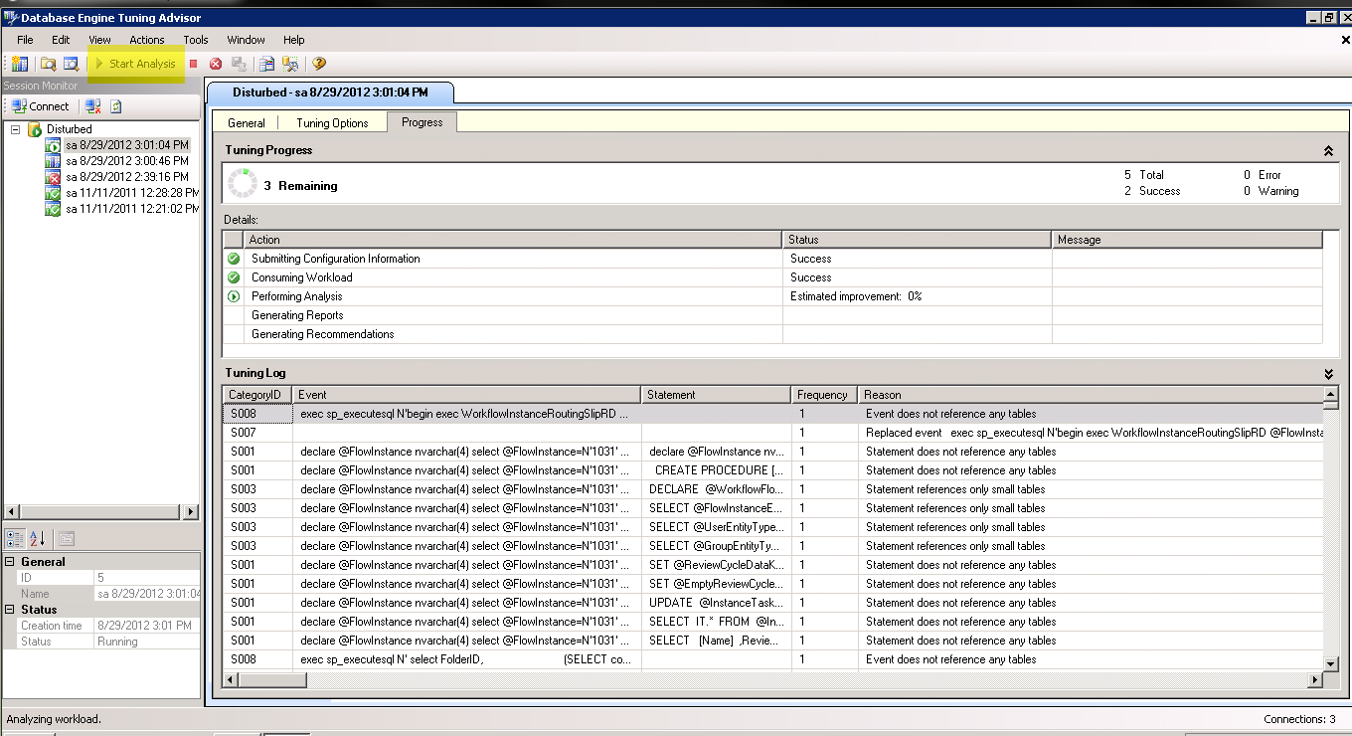

1. When complete, Choose the Actions menu, Save Recommendations

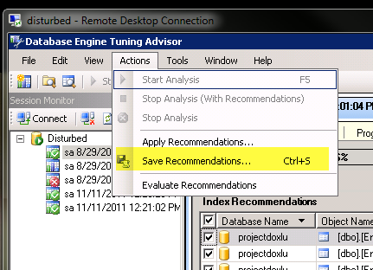

1. Save the Recommendations as a SQL file, this is for audit trail

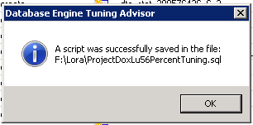

1. Apply recommended indexes and statistics.

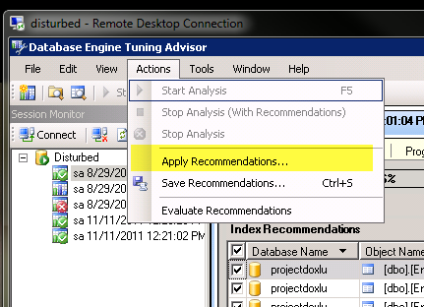

1. Test your site again with the same actions to verify improvement.